Syllabus For Spring 2019
01:460:207—Oil & Gold: The Good, The Bad & The Ugly

Description: Comprehensive introduction to the geologic setting and origin of the Earth’s natural resources. Topics include the exploitation of energy resources (oil and natural gas) and mineral deposits and the impact of the exploitation of these natural resources on our planet.

Learning Goals: Students will learn the key geologic concepts needed to discover oil, gas, and ore deposits, and apply these concepts in simulated exploration exercises. Also, students will assess and debate the ethical and societal issues related to the exploitation of natural resources.

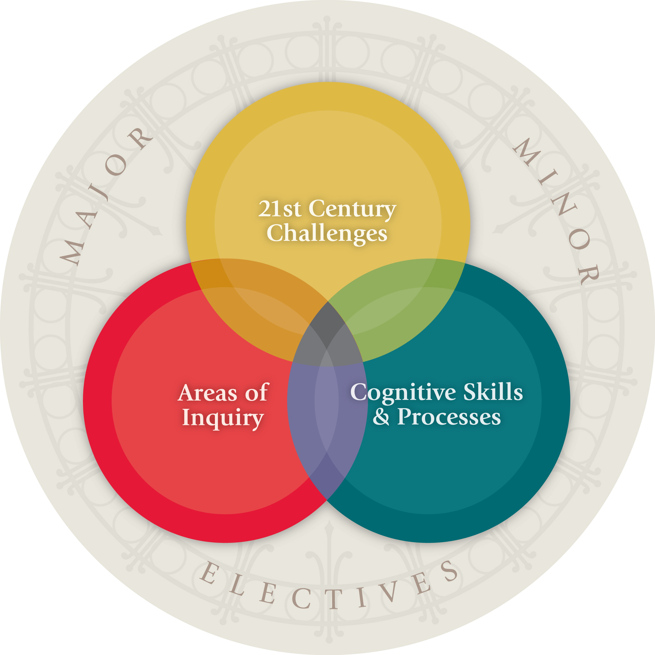
This course features an active learning environment with brief lectures, numerous hands-on activities, short writing / research assignments, and quizzes. Attendance is critical, as each new topic builds on knowledge gained in previous classes.

This course satisfies SAS Core Curriculum Goals:
NS -- Natural Sciences – Students will be able to:
e. Understand and apply basic principles and concepts in earth science.
f. Explain and be able to assess the relationship among assumptions, method, evidence, arguments, and theory in scientific analysis.
CC – Contemporary Challenges – Students will be able to:
c. Analyze the relationship that science and technology have to a contemporary social issue.

No prerequisites: The course is accessible to a wide range of students; the goals have not been met by prerequisites.

Co-Instructor: Dr. Martha Withjack
Office 243A Wright Geological Laboratory
E-mail drmeow3@eps.rutgers.edu
Office Hours: M, after class; other times by appointment

Co-Instructor: Dr. Roy W. Schlische
Office 234 Wright Geological Laboratory
E-mail schlisch@eps.rutgers.edu
Office Hours: W, 1:00-2:00 pm; other times by appointment

Basis for Grade: • Short writing assignments, class exercises, and homework: ~25%
• Weekly quizzes* (lowest quiz grade is dropped at end of semester): ~25%
• Exam 1* (02/25) and Exam 2* (04/01 & 04/08): ~25%
• Final Exam*; must be taken during scheduled time (Th, 05/09, 8:00 am): ~25%
• A: 90-100; B+: 85-89.99; B: 80-84.99; C+: 75-79.99; C: 65-74.99;
D: 50-64.99; F: 0-49.99
• Letter grades are assigned by Gradebook and are available from the Sakai course site.
* Students may bring one sheet of hand-written notes to quizzes and exams.

Required text: None. Reading assignments available on the Web or Sakai.

Assignments: (1) All assignments are due at the start of class. Late assignments are not accepted because answers are discussed in class. (2) If the assignment involves multiple exercises, the exercises must be properly numbered and submitted in the proper sequence. (3) For numerical or graphical problems, you must show all work, the final answer should be boxed, and all numerical answers should be accompanied by the proper units (e.g., 35 meters).
For assignments requiring a written answer: All answers must be typed and double-spaced. You must use complete sentences, and give the reason for your answer. Grammar, spelling, and writing style are part of your grade. Plagiarism is a serious academic offense, and we will be deal with it severely! Plagiarism includes: (1) passing off the work of others as your own; and (2) failure to acknowledge properly the source of ideas, information, facts, figures, drawings, etc., that are not your own. The following website has useful information: https://owl.english.purdue.edu/owl/resource/589/01/

Attendance: All students must attend all classes, arrive on time, remain in class until the end of the class period, and participate in class discussions. Each class session builds on material discussed in previous classes.

Electronic devices: Students must turn off and put away cell phones, laptops, tablets, and other electronic devices (except dedicated calculators) during all class sessions, quizzes, and exams.

Supplies: 3-ring binder (for holding handouts, notes, assignments, etc.; it is imperative that you keep this notebook organized), colored pencils with erasers, metric ruler, and calculator.

Schedule (subject to change except for dates of exams)

01/28 -- Week 1 – Introduction and geologic time

• Overview of course
• Pre-course assessment

• Introduction to oil & gas
• Supply, demand, and the price of oil

• Introduction to research / writing assignment – What is the future of oil? Can the world live on 100% renewables?
• Geologic time
• Team Exercise: Visualizing geologic time
• Overview of writing assignments / plagiarism

02/04 -- Week 2 – Weathering, sediments and sedimentary rocks
• Quiz on all Week 1 topics
• Discussion – What is the future of oil? Can the world live on 100% renewables?
• Weathering and origin of sediment

• Preservation and burial of sediment; compaction & cementation

• Types of sedimentary rocks

• Preliminary team exercise on identifying sediment and sedimentary rocks

• Sedimentary structures and inferring depositional environments
• Introduction to research / writing assignment – Oil-spill disasters (Santa Barbara, Valdez, Deepwater Horizon)

02/11 -- Week 3 – Source rocks and source-rock maturation
• Quiz on all Week 2 topics
• Discussion – Oil-spill disasters (Santa Barbara, Valdez, Deepwater Horizon)
• Team Exercise: Identifying sediment and sedimentary rocks

• Petroleum systems

• Gas-prone and oil-prone source rocks

• Exercise on source-rock maturation
• Introduction to research / writing assignment – West Texas Oil Boom: Good vs. Bad?

02/18 -- Week 4 – Reservoir rocks and seals
• Quiz on all Week 3 topics
• Discussion – West Texas Oil Boom: Good vs. Bad?
• Porosity and permeability
• Reservoir rocks and seals
• Deformation and geologic structures
• Overview of Exam 1

02/25 -- Week 5 – Exam 1 and plate tectonics
• Exam 1 (Weeks 1-4)
• Plate tectonics
• Plate-tectonic location of major oil/gas deposits and gold/silver deposits
• Introduction to research / writing assignment – ANWR

03/04 -- Week 6 – Geologic history / migration / conventional traps
• Quiz on ANWR and plate tectonics
• Discussion – ANWR
• Angular unconformities
• Exercise on deciphering geologic history
• Migration pathways and seals
• Conventional traps
• Class and homework exercises on finding hydrocarbon occurrences
• Introduction to research / writing assignment – Unconventional oil: Tar sands and oil shales

03/11 -- Week 7 – Block diagrams, maps, cross sections & contour lines
• Quiz on geologic history, migration, traps, finding hydrocarbons, tar sands & oil shales
• Discussion – Unconventional oil: Tar sands and oil shales
• Block diagrams, maps, and cross sections
• Contour lines
• Introduction to next writing assignment – Unconventional gas: Marcellus shale and hydrofracking

03/18: Spring Break

03/25 -- Week 8 – Contour Maps & 3D Geology
• Quiz on maps, cross sections, contour lines
• Introduction to next research / writing assignment – Unconventional gas: Marcellus shale and hydrofracking
• Exercise: Preparing a contour map
• Tying well data and cross sections
• Making maps
• Exercise: Contour maps and hydrocarbon traps

04/01 -- Week 9 – Exam 2: Team Exploration Game
• Quiz: Preparing a contour map
• Discussion – Unconventional gas: Marcellus shale and hydrofracking
• Introduction to writing assignment – The world’s largest conventional oil field: Ghawar
• Formation of teams
• Tie all wells and cross sections
• Prepare structure-contour map of reservoir unit
• Determine if source rocks are in oil window
• Complete entrapment report

04/08 -- Week 10 – Exam 2: Team Exploration
• Review of Ghawar writing assignment
• Revise entrapment report
• Drilling rounds 1, 2, and 3
• Introduction to research / writing assignment: Gold mining and mercury contamination

04/15 -- Week 11 – Igneous rocks, economics of ore deposits
• Quiz on Exploration Game Skills
• Discussion: Gold mining and mercury contamination
• Announcement of drilling results
• Introduction to writing assignment – Interview with a mineral-exploration geologist
• Introduction to research / writing assignment: Economic Resources of New Jersey
• Igneous rocks and ore deposits
• Economics of ore deposits (in-class exercise and homework)

04/22—Mineral exploration, interview
• Quiz on igneous rocks and ore deposits
• Interview with a mineral-exploration geologist
• What are ore deposits?
• How do we explore for ore deposits?
• Interview with a mineral-exploration geologist
• How do we explore for minerals?

04/29--Week 13: Economics of ore deposits, Geology Museum scavenger hunt
• Meet at Geology Museum
• Quiz on mineral exploration
• Scavenger Hunt at Geology Museum

05/06--Week 14: New Jersey Geology and resources
• Quiz on economics and ore deposits
• Geology and landscapes of New Jersey
• Economic resources of New Jersey, past and present
• Extra credit questions
• Post-course assessment

Thursday, May 9, 2019, 8:00 – 11:00 am: Comprehensive Final Exam in WL-231

Policy on Classroom Etiquette
The Department of Earth & Planetary Sciences is committed to teaching excellence. We demand that instructors (Professors, Lecturers, and Teaching Assistants) AND students display appropriate respect and consideration for each other. Instructors should try to infuse students with an enthusiastic appreciation of Geological Sciences, be well prepared for class, provide students with clear goals and expectations, listen carefully to student questions and comments, and conscientiously evaluate students' work. Students are expected to attend the scheduled classes and to behave courteously in class. Together, instructors and students will maintain an environment of openness and civility that encourages and honors the intellectual achievement represented by the discipline of Geological Sciences.
• Exams: No unexcused make-up exams will be given. Those with valid excuses will be allowed to take exams in a method determined by the instructor. To be valid, an excuse has to be obtained from the instructor prior to the exam being missed. It is a responsibility of the student to communicate with an instructor, and to keep a proof of such communication. Rare cases of extreme emergency preventing timely communication are to be discussed with the Undergraduate Director and/or Department Chair.
• Attendance: Students are expected to attend all classes; if you expect to miss one or two classes, please use the University absence reporting website https://sims.rutgers.edu/ssra to indicate the date and reason for your absence. An email is automatically sent to the instructor. [See page 2 for specific course policies.]
• Tardiness and Leaving Class Early: Students should try to not schedule courses on different campuses in adjacent periods. We recognize that some tardiness is inevitable; HOWEVER, habitually arriving in class late and departing early (or departing and returning) is disruptive and rude. We ask that you make every effort possible to get to class on time and, once there, STAY.
• Personal Conversation: It is rude and disruptive to engage in personal conversation during class. Students who persist in this disruptive behavior may be asked to leave the class and may be penalized as absent. Refusal to leave class once requested will result in disciplinary action at the Dean's level. Electronic devices should be turned off and put away during class.
• Academic Integrity: Our department fully endorses a no-tolerance cheating and plagiarism policy. If you are caught cheating, the instructor may fail you and request disciplinary action.
• Your Rights: We are all human and instructors and students both make mistakes. If you feel that you have been treated unfairly, contact the undergraduate director, Dr. Roy W. Schlische (schlische@eps.rutgers.edu) or the department chair, Dr. Greg Mountain (gmtn@eps.rutgers.edu).

Student Wellness Services
Access helpful mental health information and resources for yourself or a friend in a mental health crisis on your smartphone or tablet and easily contact CAPS or RUPD.
http://codu.co/cee05e

Counseling, ADAP & Psychiatric Services (CAPS)
(848) 932-7884 / 17 Senior Street, New Brunswick, NJ 08901
http://health.rutgers.edu/medical-counseling-services/counseling/
CAPS is a University mental health support service that includes counseling, alcohol and other drug assistance, and psychiatric services staffed by a team of professional within Rutgers Health services to support students’ efforts to succeed at Rutgers University. CAPS offer a variety of services that include: individual therapy, group therapy and workshops, crisis intervention, referral to specialists in the community and consultation and collaboration with campus partners.

Violence Prevention & Victim Assistance (VPVA)
(848) 932-1181 / 3 Bartlett Street, New Brunswick, NJ 08901
www.vpva.rutgers.edu/
The Office for Violence Prevention and Victim Assistance provides confidential crisis intervention, counseling and advocacy for victims of sexual and relationship violence and stalking to students, staff and faculty. To reach staff during office hours when the university is open or to reach an advocate after hours, call 848-932-1181.

Disability Services
(848) 445-6800 / Lucy Stone Hall, Suite A145, Livingston Campus, 54 Joyce Kilmer Avenue, Piscataway, NJ 08854
https://ods.rutgers.edu/
The Office of Disability Services works with students with a documented disability to determine the eligibility of reasonable accommodations, facilitates and coordinates those accommodations when applicable, and lastly engages with the Rutgers community at large to provide and connect students to appropriate resources.

Scarlet Listeners
(732) 247-5555
https://rutgers.campuslabs.com/engage/organization/scarletlisteners
Free and confidential peer counseling and referral hotline, providing a comforting and supportive safe space.

Report a Concern: http://health.rutgers.edu/do-something-to-help/

