Lily Serach BSc Geological Sciences 2014

Why geology?
Like many others in the field, my love of geology comes from a profound fascination and respect for the earth and a longing to understand the evolution of present-day systems.
I personally chose to study geology at Rutgers University (RU) because I am interested in how inherently interdisciplinary the field is: complex biological, chemical, and physical processes paired with deep time led to the earth we study today. The RU geology department was uniquely poised to offer hands-on undergraduate research opportunities with faculty that are at the top of their respective fields. Given the overall size of RU, this aspect of the department was exceptionally appealing to me. I had the honor of working closely with Dr. Gail Ashley on rhizolith samples from Olduvai Gorge.
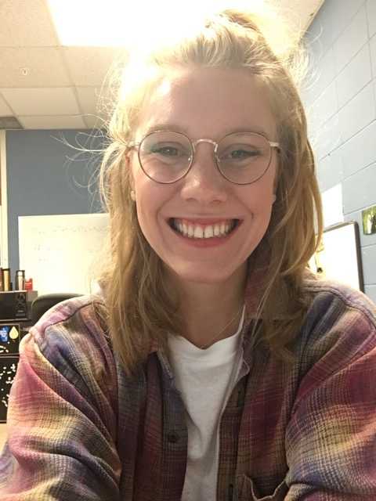

Plans for the future:
Upon the eventual completion of my degree, I hope to work on the interface between science and policy. I feel that the successful preservation of earth’s resources hinges on the ability of scientists to portray the severity of our current situation to policymakers and the public as a whole.
What I am doing now:
After graduating from RU in 2014, I moved on to the University of Texas at Austin working towards my Ph.D. in geology. I am interested in the utilization of stable isotope geochemistry to gain insight into the microbial mechanisms that stabilize soil organic carbon over time and at depth. I am particularly interested in how anthropogenic factors such as rising atmospheric CO₂ and temperature will affect the extent of carbon stabilization (or even destabilization) over time.

